OPTOELETTRONICA
a.a 2019-20

NUMERICAL SIMULATION OF SINGLE MODE SEMICONDUCTOR LASER

PART I- Guide for the use of the simulation tool

Introduction: the program simulates static and dynamic characteristics of a single mode semiconductor lasers. To make any simulation you always must run first the static analysis and then the dynamic one. The program requires indeed the results of the static analysis as inputs for the dynamic simulations.

Exercise 1: Static characteristics of single mode semiconductor laser

  - Run from the Matlab command window the program laser and choose the option “Single population (bulk)model”. Press the OK button. Choose the option Static analysis; set 1550 nm as the laser working wavelength.

  - Set first the Cavity Parameters and then the Material Parameters as shown in the following figure. Set as in the following figure and exit pressing the OK button.

Notes:
- Set the parameter β_{sp} as an array equal to [1e-4]
- Set the gain saturation parameters ε₁=0 ed ε₂=0 (run the simulations without the gain saturation!!)

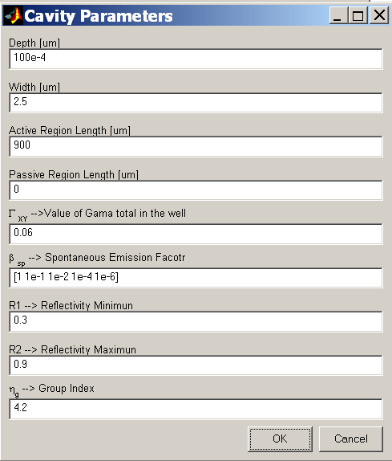
VEDI CHE r1^2 = R1 PICCOLO
[Le intestazioni laterali sono ideali per evidenziare punti importanti del testo o per aggiungere informazioni aggiuntive da usare come riferimento rapido, ad esempio una pianificazione.
In genere si trovano nella parte sinistra, destra, superiore o inferiore della pagina. Possono però essere facilmente spostati trascinandoli nella posizione preferita.
Per aggiungere contenuto, è sufficiente fare clic qui e iniziare a digitare.]

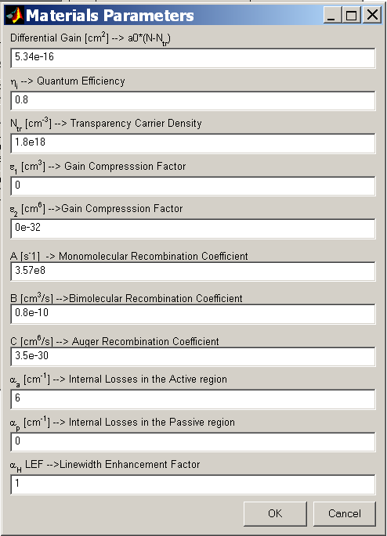

  - Set the simulation parameters for the calculation of the P-I characteristics in the section Simulation Parameters Output Power. You must set: the minimum output power, the maximum output power and the number of points in the P-I characteristic. The following figures gives an example of the typical simulation parameters. Press OK to exit.

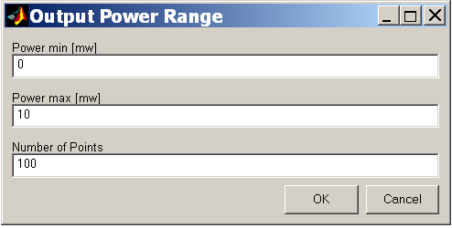

  - Press Run to calculate the P-I curve. You get as output the following graphs:
- P versus I
- Carrier density vs I
- Linewidth vs I.

  - Report the results in the section “Part II - results” of this document

EXERCISE 2: Static characteristics- Role of the laser length

2.1 Close the window laser and all the other figures. Run laser from Matlab command window and repeat the steps of point 1 setting now the following parameters:
  - β_{sp}=1e⁻⁴ (in the section Cavity Parameters)
In the section Material Parameters:
  - differential gain a₀=1e⁻¹⁶ cm²
  - α_{a}: [3] cm⁻¹
  - Check all the other parameters; must be as in the previous exercise (in particular ε₁=ε₂=0)
Run the P-I calculation setting at least 300 points in the P-I curve.

  - Repeat the simulation setting now different lengths of the active region (ie: 300um, 500 um. 900 um, 1.5mm)
Report and comment the results in the section “PART II- Results”.
EXERCISE 3: Dynamic Characteristics – IM (intensity modulation) and FM (frequency modulation) response

We calculate now the laser IM response. To run the dynamic analysis, you must run first the static analysis.

  - Run the program laser and the Static Analysis. Leave the Cavity Parameters as the default ones. Set in Material Parameters the differential gain to 1.5e⁻¹⁶ cm² and ε₁=ε₂=0. Calculate the P-I.

  - Choose the option Dynamic Analysis and set the Simulation Parameters as follows:

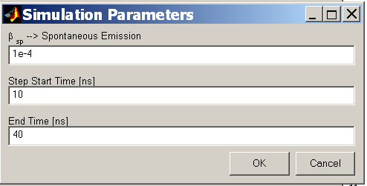
Note: the separation between “Step Start Time” and “End Time” must be at least 5ns.

  - To calculate the IM choose the option Electro-Optic in the section Type Dynamics. Set the bias point in the section Electro-Optic Parameter. The bias point is defined by the ratio I_{bias}/I_{th.} Set I_{bias}/I_{th}=2. The program displays the bias points in the static characteristics.

  - Press the Run button. You get thus the laser response to a small current step around the bias point. Observe the graphs of the output power, carrier density and frequency fluctuations. Report the results in PART II.

  - Press the button Calculate AM for the calculation of the IM response and the button Calculate FM for the calculation of the FM response. Report the results in PART II.

  - Repeat the steps 3.3, 3.4 e 3.5 changing the bias current. For example: I_{bias}/I_{th}=1.05 (just above threshold), I_{bias}/I_{th}=2, I_{bias}/I_{th}=6 and I_{bias}/I_{th}=10 and above Compare the various IM response obtained and report the results in section II.

Exercise 4: how you can simulate large signal modulation

At this point close all the figures and the program. Start the program again. Remind that to Run the Dynamic analysis it is always necessary to run first the Static Analysis

Static Analysis (repeat what done in EX1)

  - Run from the Matlab command window the program laser and chose the option “Single population (bulk)model”. Press the OK button. Choose the option Static analysis; set 1550 nm as the laser working wavelength.

  - Set first the Cavity Parameters and then the Material Parameters as shown in the following figure. Set and check the parameters to be as in the following figure and exit pressing the OK button.

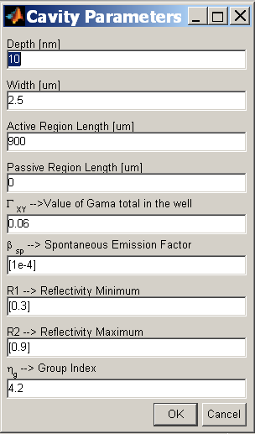

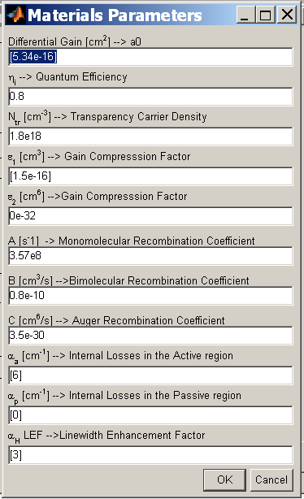
Be carefull; set this parameter

  - Set the simulation parameters for the calculation of the P-I characteristics in the section Simulation Parameters Output Power. You must set the minimum output power, the maximum output power (at least 10mW) and the number of points in the P-I characteristic. The following figures gives an example of the typical simulation parameters. Press OK to exit.

  - Press Run to calculate the P-I curve. You get as output the following graphs:
- P versus I
- Carrier density vs I
- Linewidth vs I.

Dynamic analysis for LARGE SIGNAL MODULATION OF THE LASER

  - Choose the option “Dynamic Analysis” and set the simulation parameters as shown below:

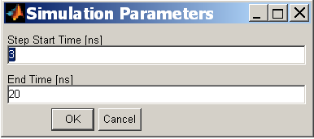

  - Choose the option “Switch on in the section “Type Dynamics””. In this case the program simulates the switch on of laser due to a current step from “Minimum Current” to “Maximum Current”. The step starts at the time instant “Step start time”. The input currents must be given as ratio respect to the threshold current I_{th}.

  - Simulate the laser switch on with a current step from 0.1 I_{th} to 5.4 I_{th}. Observe and understand the results obtained. Observed in particular how the carrier density settles to the Nth value when the transient is concluded.

of the minimum value of the current step. Report the results in the section results.

EXERCISE 5: NRZ (non-return to zero) direct modulation of the laser with a PRBS (Pseudo-Random Bit data Sequence) data

  - Close the window laser and all the other figure and run the Laser program again with the material and cavity parameters as set in point 4.2.

  - Run the dynamic analysis part and choose the simulation type PRBS signal. In this case the program simulates the direct modulation of the laser with a pseudo-random bit data sequence. The modulation current has a raised-cosine shape. As shown in the following figure the programs requires as inputs:
- the value of the current corresponding to the “zero” level (Minimum current, to be specified as ratio respect to the I_{th})
- the value of the current corresponding to the “one” level (Maximum current, to be specified as ratio respect to the I_{th})
- the modulation bit rate
- the number of bits used to generate the random sequence (ie: with 8 bits the simulator generates a sequence of 8 bits)
- NOTE: as output the program displays the laser characteristics (powers, carriers, chirp …) as function of time.

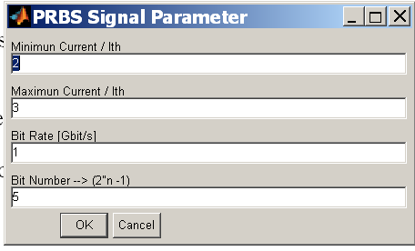

  - Choose from the calculated L-I curve the bias current and the current for the “one level” and the current for the “zero” to guarantee the following requirements:
- Bias output power: 7 dBm
- extinction-ratio ER=10 dB
Set as “PRBS Signal simulation parameters” the value of the currents calculated above, the bit rate at 2.5 Gbit/s and the bit number equal to 13

  - Run the PRBS analysis
  - Simulate the AM response of the laser at the bias current calculated in point 2.3 and measure the -3dB bandwidth.
  - Repeat the simulation of PRBS signal modulation at a higher bit rate: about 20% higher then the measured -3dB modulation bandwidth. What does it change respect to 2.5Gbit/s? Why?
  - Report the result obtained in the section “RESULTS”.

PART II- Questions and requests for the report

Exercise 1: Static characteristics of a single mode semiconductor laser
Report the figures and answer to the following questions.

  - Insert the graphs of the power, carrier density and linewidth as function of current.

  - Calculate from the material ad cavity parameters N_{th} and the threshold current I_{th} . Compare the calculated values with those obtained by the graphs.

  - Laser linewidth: Calculate from the material and cavity parameters the laser linewidth at few values of current above threshold and compare with the values obtained by the graphs.

EXERCISE 2: Static characteristics- Role of the laser length

Report the graphs of the power and carrier density obtained at the different laser length and answer to the following questions.

2.1 How the P-I changes and why?

2.2 Calculate from the material and cavity parameters the threshold current (I_{th}) and the differential quantum efficiency (η_{d}). Make a plot of threshold current and differential efficiency as function of the laser length and compare with the results obtained from numerical simulations.

EXERCISE 3: Dynamic Characteristics – IM and FM response
Report the requested graphs and answer to the questions.

  - For a fixed value of bias current I_{bias}/I_{th}, report the graphs of power, carrier density and frequency versus time. Report the graphs of IM and FM. Explain the correlation between the IM and FM response and the evolution of carrier and photon density with time.

  - Make a figure reporting on the same graph the IM responses obtained for various bias currents. Evaluate from the graphs the -3dB modulation bandwidth and make a plot of the -3dB modulation bandwidth as function of the bias current.

  - Calculate from material and cavity parameters the maximum modulation bandwidth and compare the result with the value you can estimate from point 3.2.

  - Repeat point 3.2 and 3.3 with increased gain compression factor (ε1) of one order of magnitude.

Exercise 4: Analysis of the turn-on dynamics of a single mode semiconductor laser

  - Insert the graphs of the power versus current characteristic

  - Insert the graphs of the switch-on response and comment it.

EXERCISE 5: Direct NRZ modulation of the laser with a PRBS data

  - Report the calculated power versus current characteristic and evidence the bias point and the point corresponding to the “zero” and “one” level, calculated to satisfy the requirements:
-Bias output power: 7 dBm
- Extinction-ratio ER=10 dB

  - Report the graphs of the output power, carrier density and frequency chirp as function of time obtained with PRBS modulation at 2.5 Gbit/s, 5Gbit/s, 10Gbit/s and 20Gbit/s.

  - In the graphs of the frequency chirp as function of time identify the transient and adiabatic contributions to the chirp. NOTE: The adiabatic contribution is the part of the chirp directly proportional to the output power, the transient contribution is the part proportional to the variation of the power with time (ie: proportional to the derivative of the output power).

  - Run a new PRBS simulation with a large number of bits (for example 128). Extract from the Matlab figure the data of output power (y-axis) and time (x-axis):

Select the curve and type the following commands from Matlab command window:
>>h=gco;
>> Py=get(h,’ydata’); % it returns array of Power ie: values on y-axis
>>Px=get(h,’xdata’); % it returns array of time; ie: values on x-axis

  - Write a Matlab routine for plotting the eye diagram

  - Report the graphs of the eye diagrams at different bit rates and comment them.

Le curve che ricaveremo sono state ottenute con un Guadagno lineare non logaritmico → ricorda di utilizzare la dipendenza lineare del Guadagno dai portatori
Ultimissima: quando arriverete al punto 5 (quello dello studio della dinamica del laser modulato in ampio segnale) → in questo caso quello che vi si chiede è settare dei parametri per calcolare la risposta ( questo non è il punto 2.3 ma il 5.3)

